**Experiment No 5**

**Sushant Tulasi  
D15B 64  
Batch C**

**AIM: To understand terraform lifecycle, core concepts/terminologies and install it on a Linux Machine.**

**Terraform Installation Manually:**

**Step: 1** Terraform uses HashiCorp Configuration Language (HCL) to manage environments of Operators and Infrastructure teams. To download go to site

https://www.terraform.io/downloads.html

Select the appropriate package for your operating system and architecture.

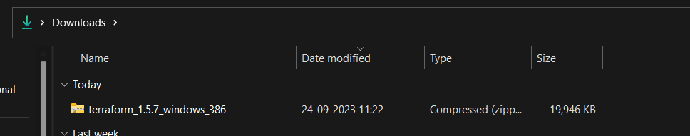

**Step 2**:Unzip the folder and extract the files

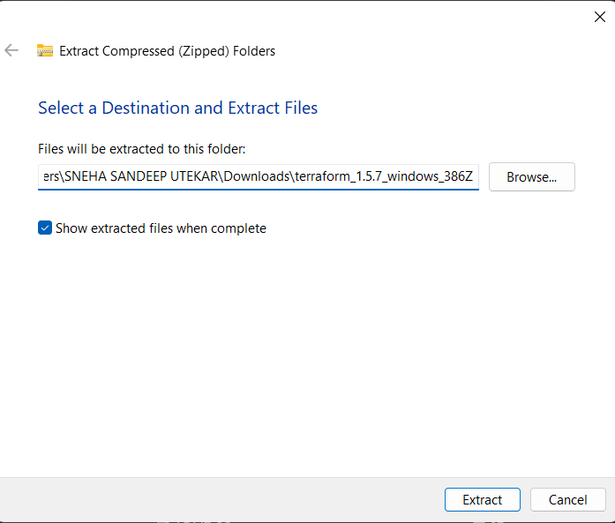

**Step 3**: Create the terraform folder in C: drive

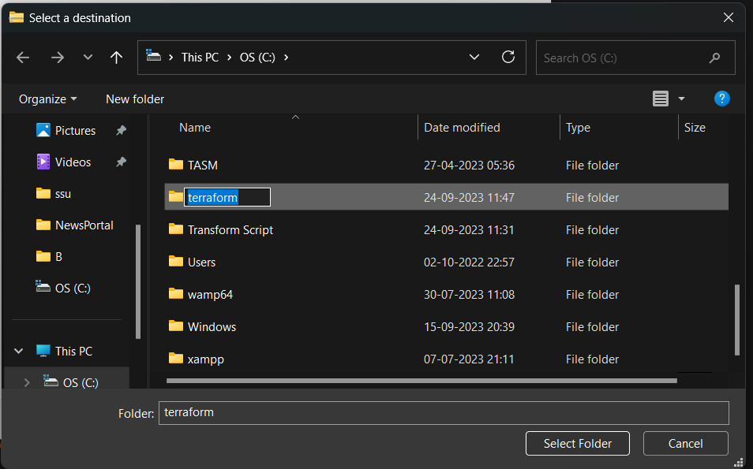

**Step 4**:Change the destination of the folder

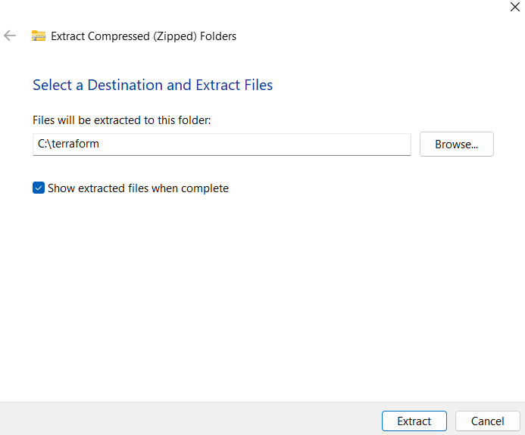

**Step 5**: Edit the user environment variables

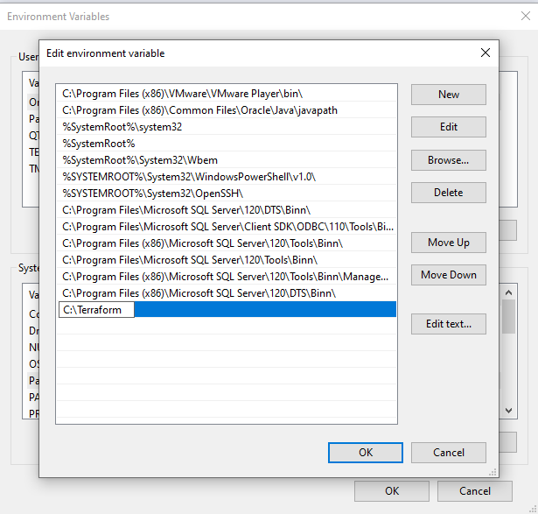

Go to path and add the new path:

**Step 6**:Check the terraform version on windows powershell

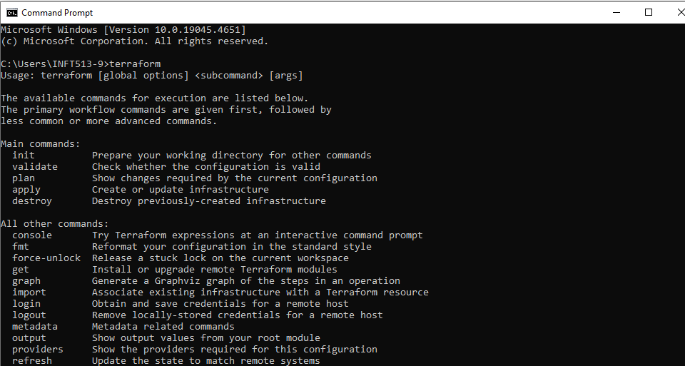

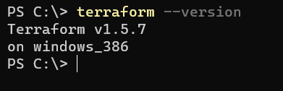

**Conclusion:** Thus, we have successfully installed the Terraform on Linux Machine and understood different terminologies.